# **Sprint 2 Plan Thru-Hiker** Sprint completion date: 5/13 Revision 1, 4/26/24

### **Goal:**

Ability to select a trail, and a home screen featuring an interactable map of the trail, and ability to track users progress from daily steps.

### **Tasks:**

* + **High Priority User Story 2.1 [8 points]**

As a user, I want the ability to choose between more potential trails.

* + **Medium Priority User Story 2.2 [5 points]**

As a user, I want to receive alerts on landmarks or points of interest I've passed through my hike after my workouts.

* + **Low Priority User Story 2.3 [3 points]**

As a user, I want to save logs of my in-progress and completed hikes so that I can review my achievements and share them with others.

Task 1: Ability to select more trails (5 hours)

Task 2: Interactive map of progress (20 hours)

* Map that has trail line/layer and a dot that shows progress

Task 3: Show previously completed hikes (15 hours)

Task 4: Integrate with apple health.

### **Roles:**

Gavin: Backend Lead

Kai: Front End Lead

Brandon: Developer/Scrum Master

Ayman: Developer

Taylor: Developer

### **Task Assignment:**

Gavin: User story/Task 1, Task 2

Kai: User story/Task 3

Brandon: User story/Task 4

Ayman: User story/Task 2

Taylor: User story/Task 2

### **Initial burndown:**

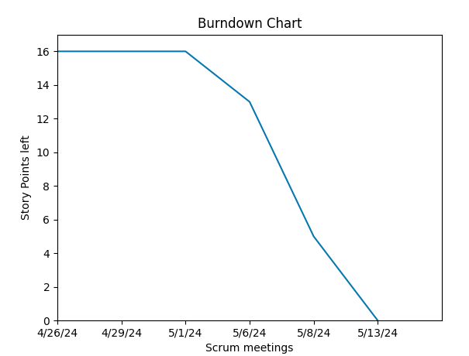

### **Initial scrum board:**

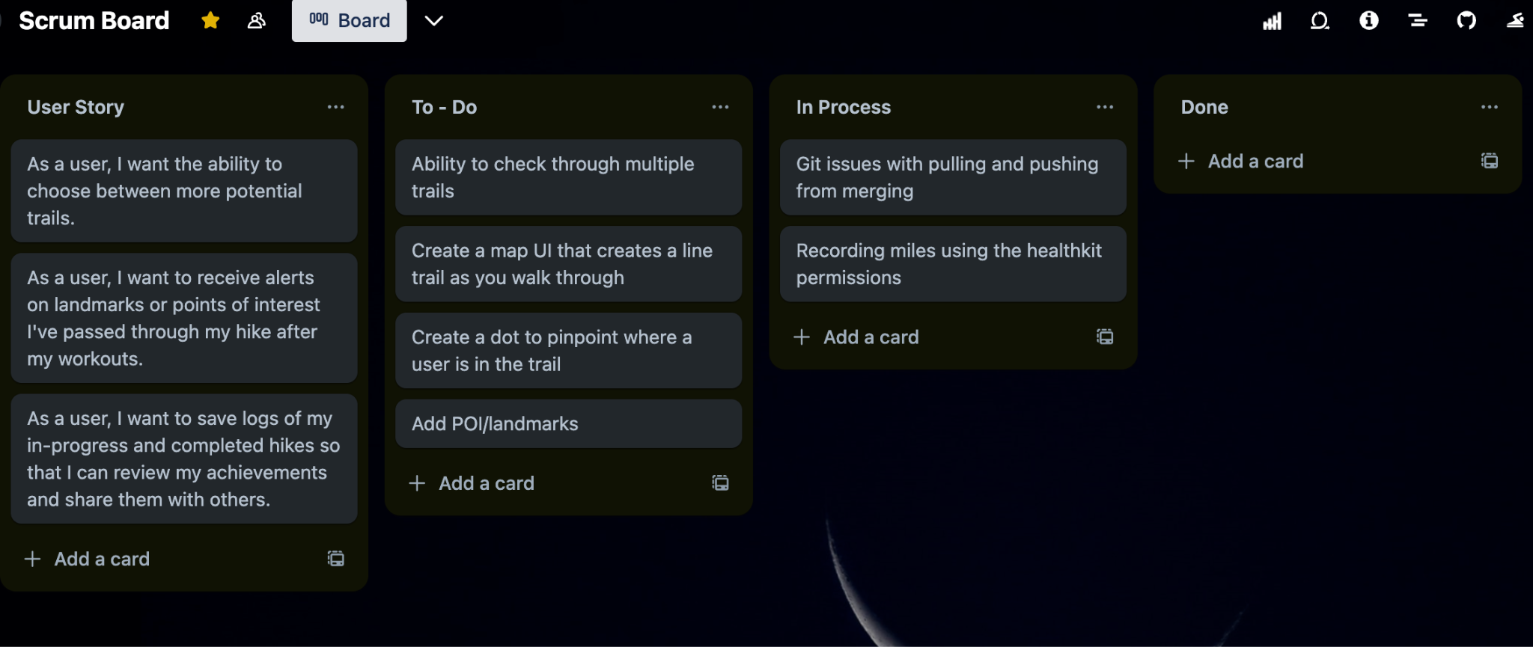

### **Scrum time:**

Monday, Wednesday, Friday 12-1pm. TA meeting on Friday 12-1pm.